Supplementary information
Zooming in on dynamics of marine microbial communities in the phycosphere of Akashiwo sanguinea (Dinophyta) blooms
Seung Won Jung^{1,*}, Joonsang Park², Junsoo Kang^{1,3}, Hyun-Jung Kim¹, Hyung Min Joo⁴, Donhyug Kang⁵, Hyojeong Seo³, Sunju Kim³, Min-Chul Jang⁶, Kyunwoo Lee², Seok Jin Oh³, Sukchan Lee⁷, Taek-Kyun Lee^{8,**},

¹Library of Marine Samples, Korea Institute of Ocean Science & Technology, Geoje, 53201, ²Marine Biotechnology Research Center, Korea Institute of Ocean Science & Technology, Busan 49111, Republic of Korea, ³Department of Oceanography, Pukyoung National University, Busan 48513, Republic of Korea, ⁴Division of Polar Ocean Science, Korea Polar Research Institute, Incheon 21990, Republic of Korea, ⁵Maritime Security Research Center, Korea Institute of Ocean Science & Technology, Busan 49111, Republic of Korea, ⁶Ballast Water Research Center, Korea Institute of Ocean Science and Technology, Geoje, 53201, Republic of Korea, ⁷Department of Genetic Engineering, Sungkyunkwan University, Suwon, Republic of Korea, ⁸Risk Assessment Research Center, Korea Institute of Ocean Science & Technology, Geoje 53201, Republic of Korea

*Corresponding author: S.-W. Jung, diatoms@kiost.ac.kr, Fax: +82-55-639-8429
** Co-corresponding author: T.K. Lee, tklee@kiost.ac.kr, Fax: +82-55-635-3913

Running title: Microbial dynamics in Akashiwo sanguinea HABs
Key words: Akashiwo sanguinea HABs, environmental change, endoparasitic Amoebophrya sp., microbial communities, nucleocytoplasmic large DNA viruses, network analysis
Supplementary Figures
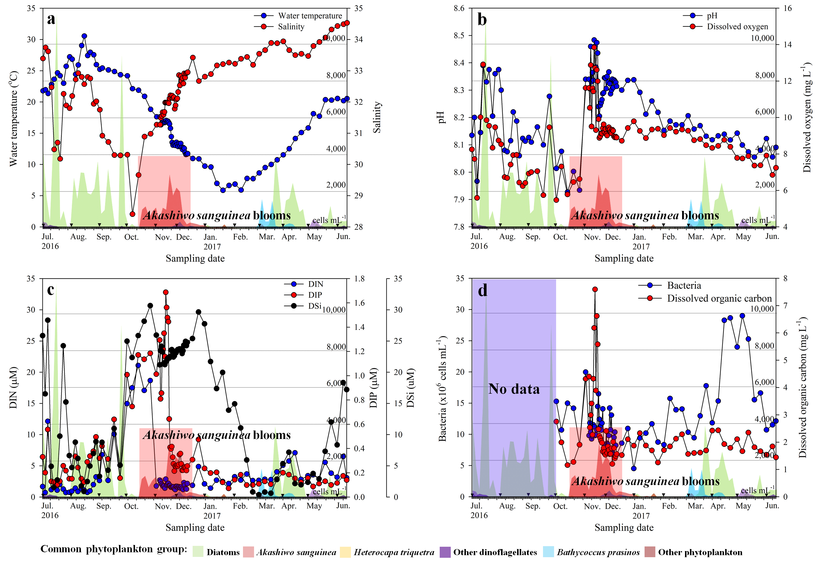
Supplementary Figure 1. Weekly and daily changes in the measured environmental factors and phytoplankton communities in Jangmok Bay Time-series Monitoring Site (JBTMS) from June 2016 to June 2017. a, water temperature and salinity; b, pH and dissolved oxygen; c, dissolved inorganic nitrogen (DIN), dissolved inorganic phosphorus (DIP), and dissolved silica (DSi); d, total bacterial abundance and dissolved organic carbon concentration.

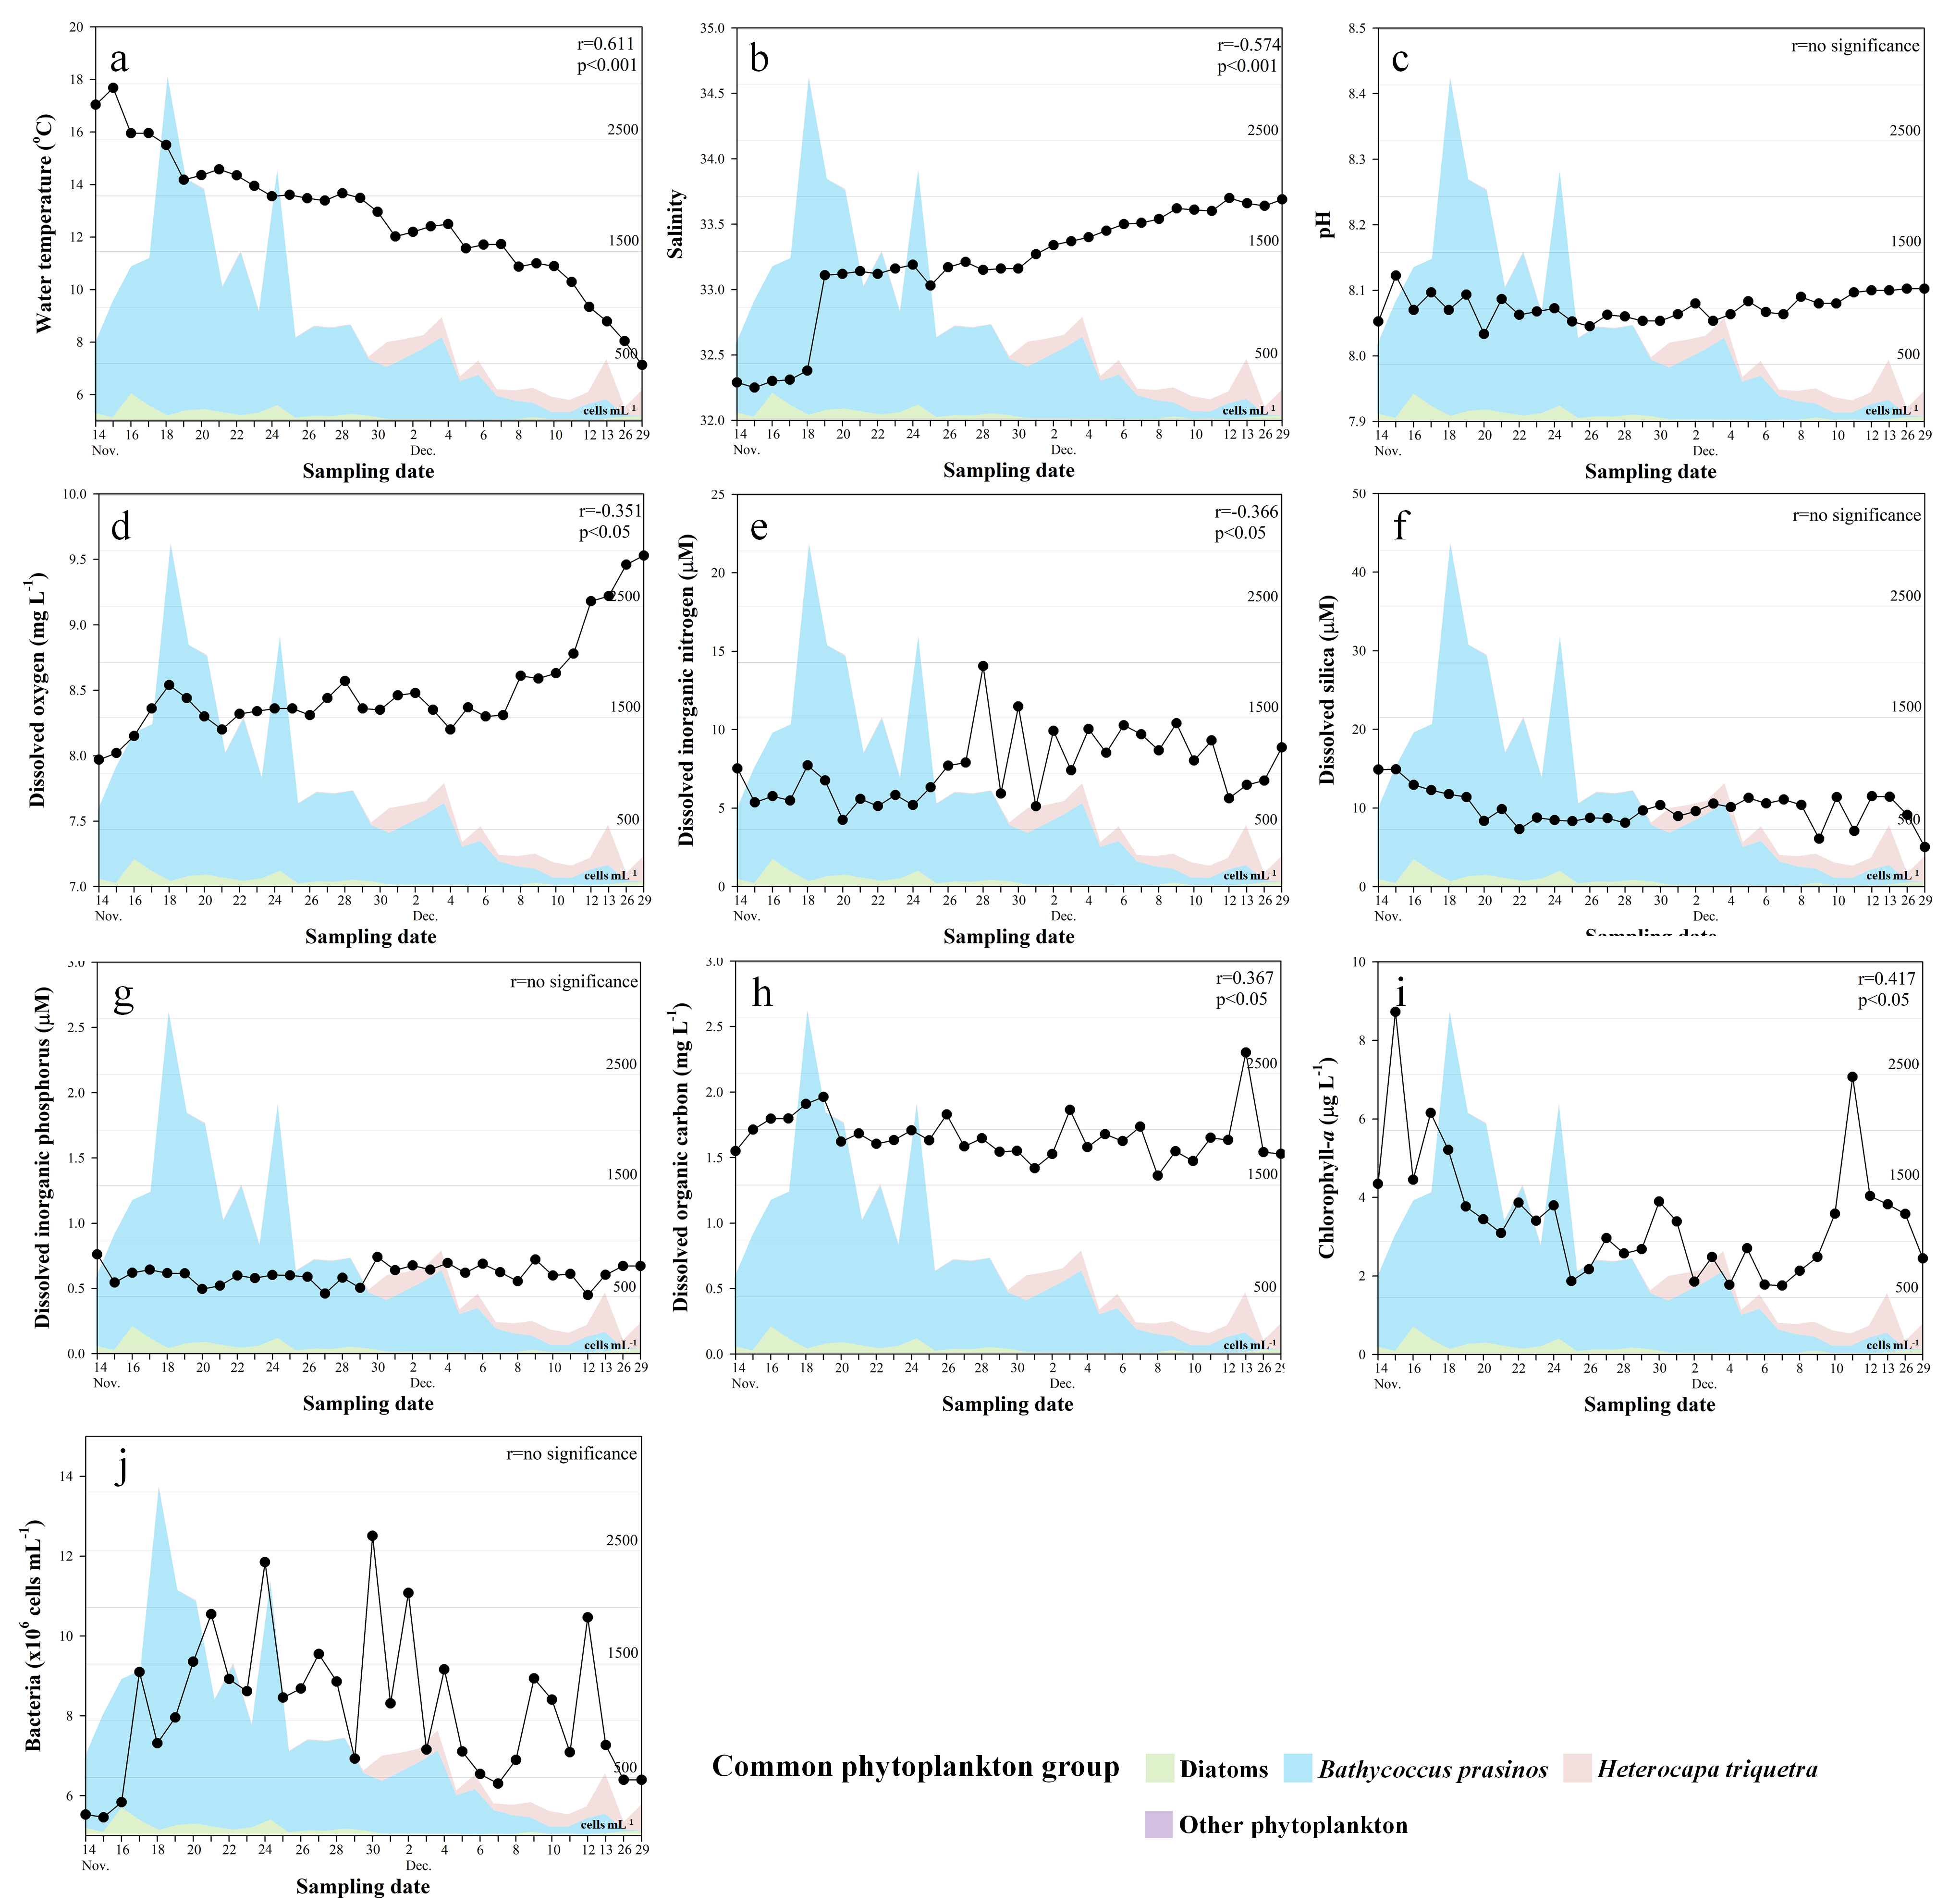
Supplementary Figure 2. Daily changes in environmental factors under dominant presence of the pico-sized green alga, Bathycoccus prasinos in 2017. a, water temperature; b, salinity; c, pH; d, dissolved oxygen; e, dissolved inorganic nitrogen; f, dissolved silica; g, dissolved inorganic phosphorus; h, dissolved organic carbon; i, chlorophyll-a; j, total bacteria abundance. Coloured areas in the figure correspond to the common phytoplankton groups in 2017. r value in each figure (upper right) indicates Pearson correlation coefficient between changes in each environmental factor and B. prasinos abundance.

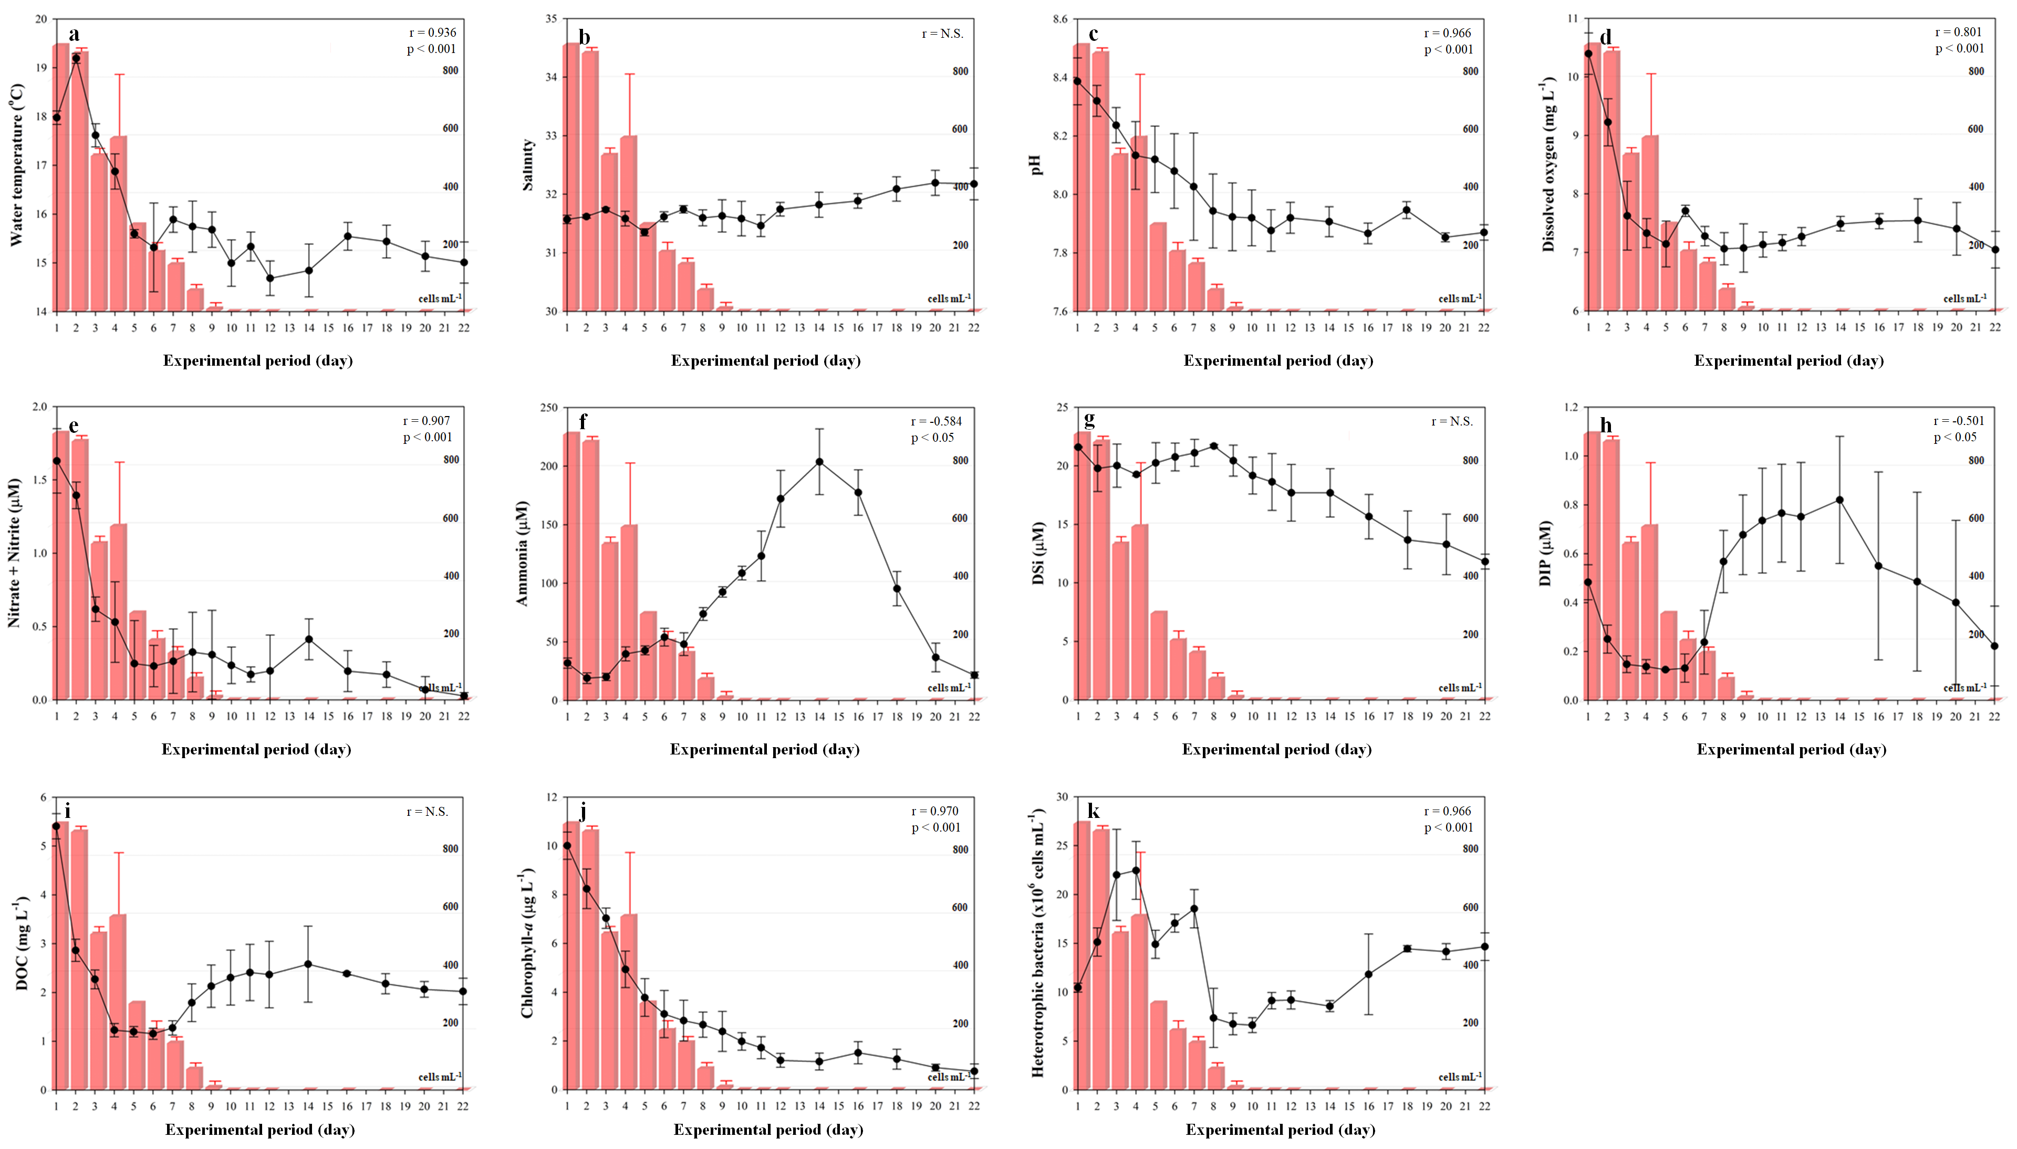
Supplementary Figure 3. Daily changes in environmental factors and Akashiwo sanguinea abundance in indoor-microcosm. a, water temperature; b, salinity; c, pH; d, dissolved oxygen; e, nitrate and nitrite; f, ammonia; g, dissolved silica (DSi); h, dissolved inorganic phosphorus (DIP); i, dissolved organic carbon (DOC); j, chlorophyll-a concentration; k, total bacteria abundance. The red-coloured bar is represented as a mean value (triplicate experiments) of A. sanguinea abundance and error bar indicates standard deviation. r value in each figure (upper right) indicates Pearson correlation coefficient between changes in each environmental factor and A. sanguinea abundance.

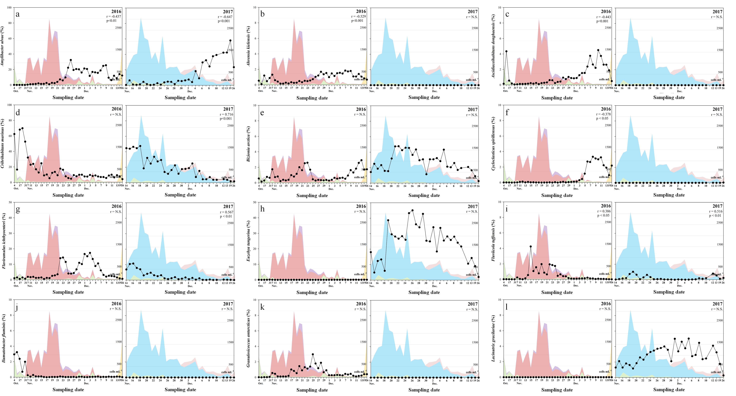
Supplementary Figure 4. Daily changes in the most abundant bacterial species (each displaying a relative abundance >1 % in at least one sample) in 2016 and 2017. The coloured areas in the figure correspond to the common phytoplankton groups in 2016 and 2017. r values in each figure (upper right) indicate Pearson correlation coefficient between common the bacterium and A. sanguinea abundance in 2016 and Bathycoccus prasinos abundance in 2017.
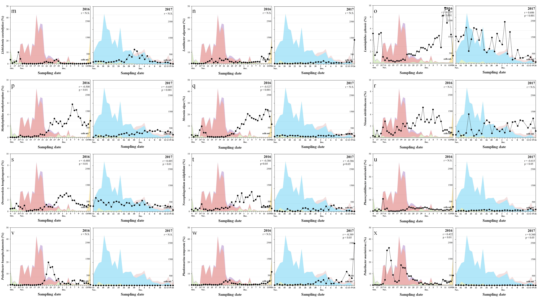
Supplementary Figure 4. Continued.

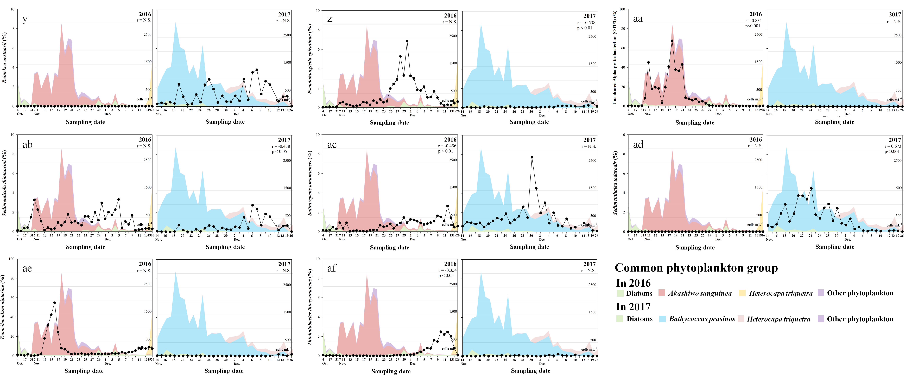
Supplementary Figure 4. Continued.

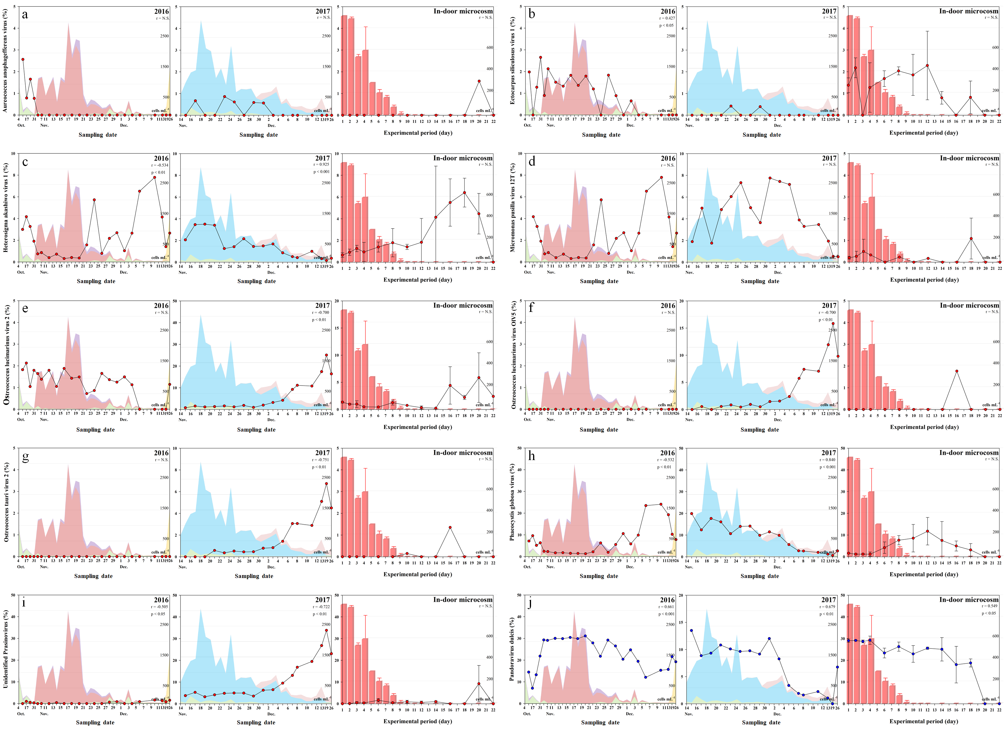
Supplementary Figure 5. Daily changes in the most abundant nucleo-cytoplasmic large DNA viruses (NCLDVs) (each displaying a relative abundance >1 % in at least one sample) in 2016, 2017, and in-door microcosm. The coloured areas correspond to the common phytoplankton groups in 2016 and 2017, respectively. The red-coloured bar is represented as a mean value (triplicate experiments) of A. sanguinea abundance and error bar indicates standard deviation. a−i, Phycodnaviridae (a, Aureococcus anophagefferens virus; b, Ectocarpus siliculosus virus 1; c, Heterosigma Akashiwo virus 1; d, Micromonas pusilla virus 12T; e, Ostreococcus lucimarinus virus 2; f, Ostreococcus lucimarinus virus OIV5; g, Ostreococcus tanuri virus 2; h, Phaeocystis globose virus; i, Unidentified Prasinovirus); j−m, Pandoraviridae (j, Pandoravirus dulicis; k, Pandoravirus inopinatum; l, Pandoravirus salinus; m, Unidentified Pandoravirus); n−r, Poxviridae (n, Cowpox virus; o, Nile crocodilepox virus; p, Pseudocowpox virus; q, Squirrelpox virus Berlin 2015; r, Unidentified Orthopox virus); s, Mimiviridae (Cafeteria roenbergensis virus BV-PW1); t, Iridoviridae (Ranavirus maximus). r values in each figure (upper right) indicate Pearson correlation coefficients between changes in each environmental factor and A. sanguinea abundance in 2016 and Bathycoccus prasinos abundance in 2017.
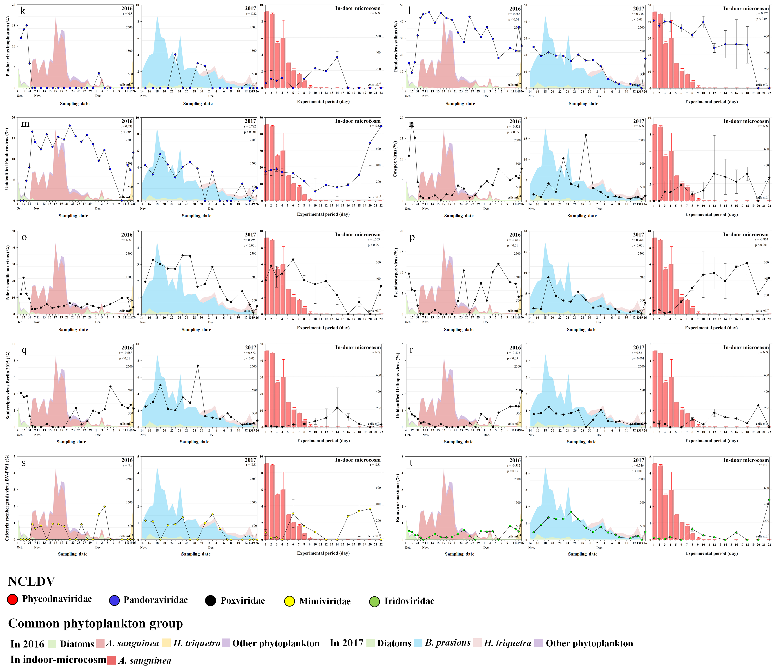
Supplementary Figure 5. Continued.
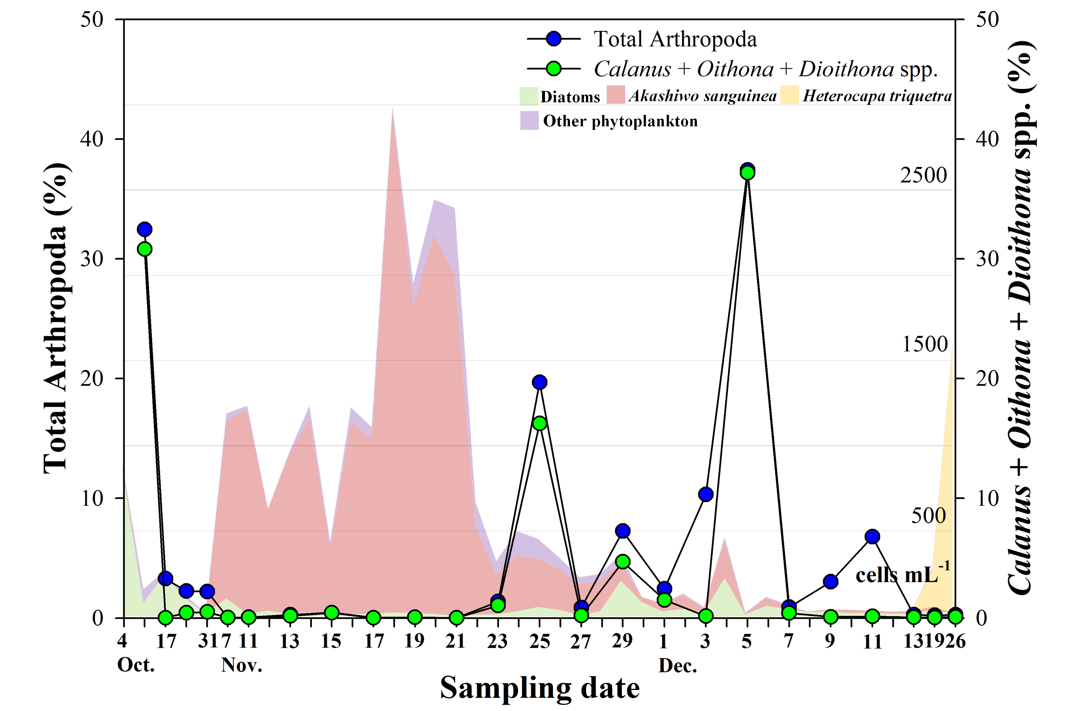
Supplementary Figure 6. Daily changes in relative abundance (%) of the microzooplankton (total Arthropoda) communities and Akashiwo sanguinea feeding herbivores (Calanus spp. + Oithona spp. + Dioithona spp.) obtained from metagenomic next-generation sequencing during Akashiwo sanguinea blooms in 2016, The coloured areas in the figure correspond to the common phytoplankton groups in 2016.

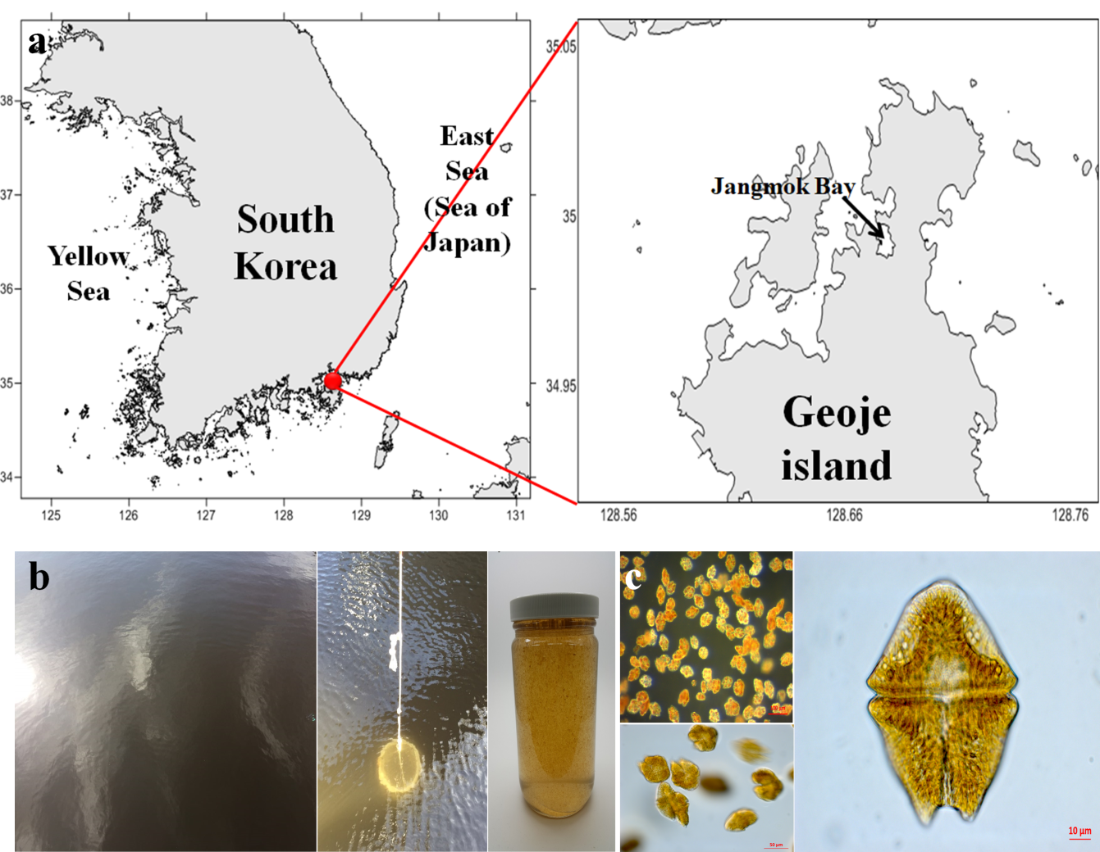
Supplementary Figure 7. Sampling site located in Jangmok Bay Time-series Monitoring Site (JBTMS: 34° 59´ 37´´ N and 128° 40´ 27´´ E), a semi-closed bay on the southern coast of South Korea a. b, sea water colour in Akashiwo sanguinea bloom; c, light microscopic observation of Akashiwo sanguinea cell.
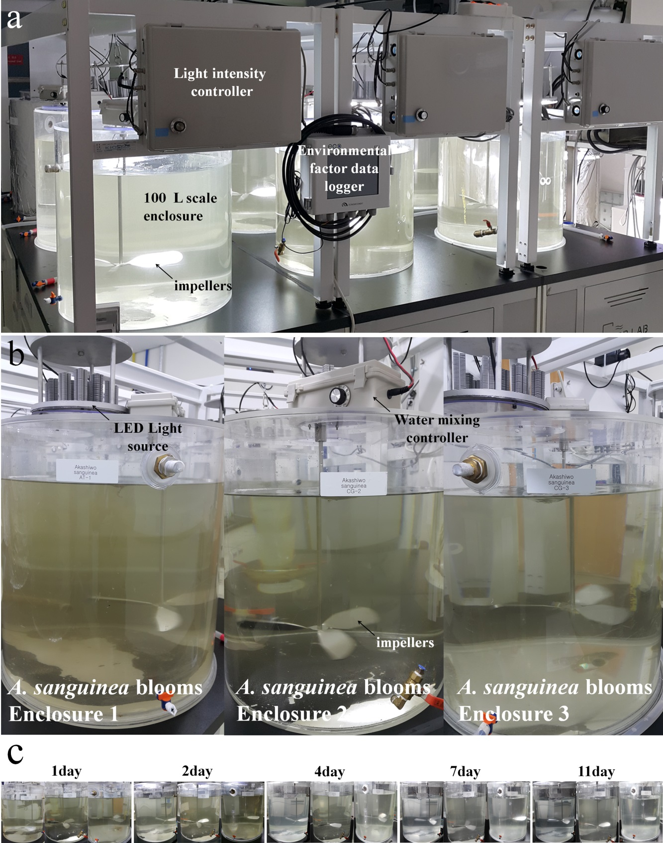
Supplementary Figure 8. a, A 100-L scale in-door microcosm complex; b, three replicate microcosm experiments in seawater of Akashiwo sanguinea bloom; c, time series photographs of three replicate microcosms. Each enclosure consisted of LED light with light intensity controller, impellers with water mixing controller, and data logger of measured environmental factors.

Supplementary Tables
Supplementary Table 1. Summary of numbers of read counts and operational taxonomic units (OTUs) of bacterial community (16s rDNA V3-V4 regions) obtained from metagenomic next-generation sequencing analysis and the alpha-diversity indices of the Jangmok Bay Time-series Monitoring Site in 2016 (Akashiwo sanguinea bloom) and 2017 (No Akashiwo sanguinea bloom). Groups I−IV were obtained from nMDS analysis presented in Figs. 2a and 2b.
Group | Date | Total sequence (mean) | Read Count (mean) | OTUs  (mean) | Chao1 richness (mean) | Shannon diversity  (mean) | Simpson evenness (mean) | Remark
Group I | Oct., 4 - 31, 2016 | 32,298,622-62,271,417 (46,112,019) | 73,321-140,807 (104,034) | 261-406 (313) | 407-677 (489) | 2.804-3.680 (3.316) | 0.564-0.773 (0.678) | Before A. sanguinea bloom
Group II | Nov., 7 – 28, 2016 | 7,696,433-44,490,558 (23,987,481) | 17,197-99,823 (53,723) | 113-220 (162) | 157-343 (242) | 2.373-4.791 (3.791) | 0.538-0.930 (0.821) | During A. sanguinea bloom
Group III | Nov., 13 – 14, 2016 | 7,397,953-13,327,844 (10,362,899) | 16,499-29,667 (23,083) | 104-119 (112) | 178-199 (188) | 2.988-3.107 (3.047) | 0.798-0.807 (0.802) | During A. sanguinea bloom
Group IV | Nov., 29 – Dec., 26, 2016 | 23,022,820-82,174,372 (54,400,274) | 51,437-183,273 (121,405) | 179-296 (241) | 245-433 (351) | 4.380-4.837 (4.614) | 0.893-0.939 (0.917) | After A. sanguinea bloom
Group I | Nov., 14 – Dec., 13, 2017 | 8,656,023-69,720,710 (31,791,259) | 19,470-156,620 (71,464) | 135-310 (207) | 176-434 (288) | 3.539-4.295 (3.935) | 0.759-0.889 (0.823) | Dominance of B. prasinos
Group II | Dec., 19 – 26, 2017 | 6,804,524-7,552,004 (7,178,264) | 15,400-17,180 (16,290) | 105-109 (107) | 167-169 (168) | 2.971-3.025 (2.998) | 0.662-0.768 (0.715) | After decrease of B. prasinos

Supplementary Table 2. Summary of numbers of read counts and operational taxonomic units (OTUs) of Nucleo-Cytoplasmic Large DNA Viruses (NCLDVs) obtained from metagenomic next-generation sequencing analysis of the Jangmok Bay Time-series Monitoring Site in 2016 (Akashiwo sanguinea blooming period) and 2017 (No Akashiwo sanguinea bloom period). Groups I−IV were obtained from nMDS analysis presented in Figs. 2c and 2d.
Group | Date | Total sequence (mean) | Virus reads (mean) | NCLDVs reads (mean) | NCLDVs OTUs (mean) | Remark
Group I | Oct.10-31, 2016 | 1,688,012,192-2,155,833,284 (1,938,029,006) | 31,520-125,170 (75,564) | 14,070-66,258 (40,391) | 18-21 (19) | Before A. sanguinea bloom
Group II | Nov. 7-13, 17-21, 27, 2016 | 1,464,097,818-2,233,117,474 (1,947,532,933) | 130,145-272,032 (192,522) | 100,934-212,204 (152,223) | 14-17 (15) | During A. sanguinea bloom
Group III | Nov. 15, 23-25, 2016 | 1,651,836,012-2,358,455,848 (2,037,260,361) | 41,206-86,962 (58,708) | 29,748-61,080 (40,383) | 15-17 (16) | During A. sanguinea bloom
Group IV | Nov.29, Dec. 1- 26, 2016 | 1,171,719,382-2,160,505,544 (1,642,238,094) | 8,178,29,862 (15,403) | 2,404-11,480 (6,047) | 13-19 (17) | After A. sanguinea bloom
Group I | Nov., 15-Dec., 3, 2017 | 1,541,147,082-2,348,387,360 (1,892,553,756) | 7,128-25,776 (15,367) | 3,294-11,206 (6,946) | 19-33 (26) | Dominance of B. prasinos
Group II | Dec., 5-13, 2017 | 2,016,479,140-2,120,355,620 (2,079,140,712) | 13,608-44,718 (26,373) | 8,124-29,974 (16,504) | 24-29 (26) | After decrease of B. prasinos
Group III | Dec. 19-26, 2017 | 1,645,685,920-2,382,864,316 (2,014,275,118) | 59,048-89,438 (74,243) | 49,584-52,074 (50,829) | 20-25 (23) | After decrease of B. prasinos

Supplementary Table 3. Summary of mean number (triplicate experiments) of read counts and operational taxonomic units (OTUs) of Nucleo-Cytoplasmic Large DNA Viruses (NCLDVs) obtained from metagenomic next-generation sequencing analysis of in-door microcosm experiment. Groups I−V were obtained from nMDS analysis (similarity: 70 %).
Group | Sampling date (Experimental Day) | Total sequence (mean) | Virus reads (mean) | NCLDVs reads (mean) | NCLDVs OTUs (mean)
Group I | 1, 2 | 1,578,211,860 - 1,944,800,248 (1,761,506,054) | 30,950 - 40,235 (35,593) | 23,029 - 30,406 (26,718) | 16 - 17 (17)
Group II | 3, 4, 6, 8, 10, 12, 14, and 18 | 1,442,436,853 - 2,115,153,043 (1,738,088,766) | 2,621 - 10,716 (6,812) | 1,586 - 5,429 (3,116) | 13 - 23 (18)
Group III | 16 | 1,454,345,662 | 2,239 | 955 | 18
Group IV | 20 | 1,721,847,495 | 596 | 312 | 9
Group V | 22 | 1,985,119,044 | 487 | 228 | 8

Supplementary Table 4. Summary of number of read counts and operational taxonomic units (OTUs) of eukaryotic plankton community (18s rDNA V4-V5 regions) at size-fractions of >10 μm (focused on eukaryotic plankton and dinospores of Amoebophrya sp. in A. sanguinea cells) and 3−0.2 μm (focused on free-living Amoebophrya spp. and nano-sized phytoplankton) obtained from metagenomic next-generation sequencing analysis, and alpha-diversity indices of the Jangmok Bay Time-series Monitoring Site in 2016 (Akashiwo sanguinea blooming period). Groups I−III (>10 μm) and Groups I−V (3-0.2 μm) were obtained from nMDS analysis (similarity: 40% and 50%, respectively).
Filter size | Group | Sampling date | Total sequence (mean) | Read Count (mean) | OTUs (mean) | Chao1 richness (mean) | Shannon diversity (mean) | Simpson evenness (mean) | Remark
> 10 um | Group I | Oct. 10-31, 2016 | 12,478,827-47,051,009 (26,192,373) | 30,295-113,485 (63,407) | 208-289 (256) | 273-353 (328) | 3.373-4.983 (4.216) | 0.715-0.919 (0.849) | Before A. sanguinea bloom
> 10 um | Group II | Nov.-7-23, 2016 | 11,388,538-69,954,522 (48,129,687) | 27,244-167,974 (115,268) | 59-160 (112) | 101-243 (195) | 0.108-0.805 (0.313) | 0.018-0.275 (0.076) | During A. sanguinea bloom
> 10 um | Group III | Nov.25-Dec.26 | 6,547,198-107,637,393 (49,803,387) | 15,642-257,281 (118,832) | 114-307 (208) | 193-403 (300) | 0.758-2.437 (1.868) | 0.191-0.693 (0.521) | After A. sanguinea bloom
3-0.2 um | Group I | Nov. 11-21, 2016 | 20,334,734-33,137,157 (27,951,474) | 48,658-78,547 (66,663) | 144-234 (185) | 156-286 (240) | 0.656-2.674 (1.842) | 0.119-0.716 (0.455) | During A. sanguinea bloom
3-0.2 um | Group II | Nov. 23-Dec.26, 2016 | 20,987,838-49,915,365 (30,248,955) | 50,178-118,849 (72,405) | 216-329 (282) | 229-389 (327) | 2.084-5.916 (4.560) | 0.464-0.964 (0.845) | After A. sanguinea bloom
3-0.2 um | Group III | Dec. 13, 2016 | 9,663,458 | 23,109 | 201 | 214 | 5.940 | 0.960 | After A. sanguinea bloom
3-0.2 um | Group I | Nov. 15 - Dec. 26, 2017 | 28,278,227-61,578,514 (45,329,554) | 68,221-147,961 (108,980) | 176-392 (306) | 257-454 (367) | 2.065-5.285 (3.970) | 0.517-0.942 (0.820) | No A. sanguinea bloom
3-0.2 um | Group II | Nov. 17, 2017 | 17,867,369 | 42,759 | 207 | 224 | 5.698 | 0.951 | No A. sanguinea bloom
Supplementary Table 5. Summary of number of read counts and operational taxonomic units (OTUs) of eukaryotic plankton community (18s rDNA V4-V5 regions) at size-fractioned >10 μm (focused on eukaryotic plankton and dinospores of Amoebophrya sp. in A. sanguinea cells) and 3−0.2 μm (focused on free-living Amoebophrya spp. and nano-sized phytoplankton) obtained from next-generation sequencing analysis and the alpha-diversity indices of in-door microcosm experiment. Groups I and II (>10 and 3−0.2 μm, respectively) were divided by nMDS analysis (both at 40 % similarity).
Filter size | Group | Sampling date (Experimental day) | Total sequence (mean) | Read Count (mean) | OTUs (mena) | Chao1 richness (mean) | Shannon diversity (mean) | Simpson evenness (mean)
> 10 um | Group I | First 10 days (1-10 days) | 17,667,360-79,953,073 (41,738,758) | 41,962-190,488 (99,652) | 136-252(183) | 156-339 (235) | 0.857-4.360 (2.129) | 0.182-0.895 (0.552)
> 10 um | Group II | Last 10 days (12-22 days) | 7,368,658-41,675,851 (23,631,289) | 17,574-101,012 (56,536) | 110-224 (162) | 133-251 (201) | 0.864-5.248 (3.062) | 0.204-0.937 (0.708)
3-0.2 um | Group I | First 6 days (1-6 days) | 14,318,742-60,260,291 (35,679,871) | 33,508-143,687 (84,230) | 155-354 (243) | 163-389 (270) | 2.841-5.256 (3.792) | 0.616-0.944 (0.809)
3-0.2 um | Group II | Last 14 days (8-22 days) | 7,419,108-63,515,759 (36,729,428) | 17,774-150,637 (87,635) | 57-209 (120) | 76-251 (157) | 0.593-5.529 (1.896) | 0.131-0.951 (0.448)

Supplementary Table 6. Abbreviations of factors and node sizes in the Network analysis displayed in Fig. 6 in 2016 and 2017
2016 |  |  | 2017
Factor | Abbreviation | Node size | Factor | Abbreviation | Node size | Classification
Temperature | Temp. | 0.47 | Temperature | Temp. | 0.47 | Environmental factor
Salinity | Sal. | 0.63 | Salinity | Sal. | 0.67 | Environmental factor
pH | pH | 0.48 | pH | pH | 0.39 | Environmental factor
Dissolved inorganic nitrogen | DIN | 0.35 | Dissolved inorganic nitrogen | DIN | 0.37 | Environmental factor
Dissolved inorganic phosphorus | DIP | 0.26 | Dissolved organic carbon | DOC | 0.34 | Environmental factor
Dissolved organic carbon | DOC | 0.23 | Chlorophyll-a | Chl-a | 0.29 | Environmental factor
Chlorophyll-a | Chl-a | 0.29 | Dissolved oxygen | DO | 0.35 | Environmental factor
Dissolved oxygen | DO | 0.25 | Dissolved silica | DSi | 0.45 | Environmental factor
Akashiwo sanguinea | Aka.san. | 0.63 | Akashiwo sanguinea | Aka.san. | 0.21 | Autotroph
Heterocapsa rotundata | Het.rot. | 0.23 | Heterocapsa rotundata | Het.rot. | 0.36 | Autotroph
Uncultured stramenopile | Unk.Sta. | 0.28 | Bathycoccus prasinos | Bat.pra. | 0.47 | Autotroph
 |  |  | Chaetoceros sp. | Cha.sp. | 0.30 | Autotroph
 |  |  | Teleaulax sp. | Tel.sp. | 0.40 | Autotroph
 |  |  | Pyramimonas australis | Pyr.aus. | 0.35 | Autotroph
 |  |  | Thalassiosira oceanica | Tha.oce. | 0.43 | Autotroph
 |  |  | Chaetoceros tenuissimus | Cha.ten. | 0.28 | Autotroph
 |  |  | Teleaulax amphioxeia | Tel.amp. | 0.44 | Autotroph
 |  |  | Tetraselmis sp. | Tet.sp. | 0.12 | Autotroph
 |  |  | Minutocellus sp. | Min.sp. | 0.13 | Autotroph
 |  |  | Adenoides eludens | Ade.elu. | 0.08 | Autotroph
Paracalanus parvus | Par.par. | 0.22 | Strombidium caudispina | Sto.cau. | 0.18 | Heterotroph
Calanus sinicus | Cal.sin. | 0.06 | Strombidium capitatum | Sto.cap. | 0.10 | Heterotroph
Acartia steueri | Aca.ste. | 0.09 | Noctiluca scintillans | Noc.sci. | 0.22 | Heterotroph
Centropages hamatus | Cen.ham. | 0.06 | Strombidium sp. | Sto.sp. | 0.18 | Heterotroph
Oithona davisae | Oit.dav. | 0.09 | Clytia hemisphaerica | Cly.hem. | 0.07 | Heterotroph
Acartia omorii | Aca.omo. |  | Laackmanniella prolongata | Laa.pro. | 0.30 | Heterotroph
Amoebophrya sp1. | Amo.sp1. | 0.21 | Amoebophyra sp.2 | Amo.sp2. | 0.17 | Endoparasitic dinoflagellate
Other Syndiniales | Oth.Syn. | 0.29 | Other Syndiniales | Oth.Syn. | 0.11 | Endoparasitic dinoflagellate
Novosphingobium acidiphilum | Nov.aci. | 0.35 | Alphaproteobacteria | Alphapro. | 0.42 | Bacteria
Ahrensia kielensis | Ahr.kie. | 0.44 | Flavobacteriales | Flavobac. | 0.43 | Bacteria
Ascidiaceihabitans donghaensis | Asc.don. | 0.25 | Betaproteobacteria | Betapro. | 0.46 | Bacteria
Uncultured Alpha-proteobacterium (OUT #2) | Ualphapro. | 0.18 | Actinobacteria | Actinob. | 0.53 | Bacteria
Cribrihabitans marinus | Cri.mar. | 0.34 | Sedimentitalea todarodis | Sed.tod. | 0.33 | Bacteria
Amylibacter ulvae | Amy.ulv. | 0.32 | Novosphingobium acidiphilum | Nov.aci. | 0.31 | Bacteria
Lentibacter algarum | Len.alg. | 0.36 | Cribrihabitans marinus | Cri.mar. | 0.36 | Bacteria
Nisaea nitritireducens | Nis.nit. | 0.38 | Amylibacter ulvae | Amy.ulv. | 0.31 | Bacteria
Planktomarina temperate | Pla.tem. | 0.22 | Lentibacter algarum | Len.alg. | 0.32 | Bacteria
Tenacibaculum aiptasiae | Ten.aip. | 0.13 | Nisaea nitritireducens | Nis.nit. | 0.40 | Bacteria
Polaribacter marinivivus | Pol.mar. | 0.19 | Planktomarina temperata | Pla.tem. | 0.24 | Bacteria
Flaviramulus ichthyoenteri | Fla.ich. | 0.32 | Tenacibaculum aiptasiae | Ten.aip. | 0.21 | Bacteria
Lishizhenia caseinilytica | Lis.cas. | 0.15 | Flaviramulus ichthyoenteri | Fla.ich. | 0.23 | Bacteria
Mesonia algae | Mes.alg. | 0.36 | Lishizhenia caseinilytica | Lis.cas. | 0.25 | Bacteria
Phaeocystidibacter marisrubri | Pha.mar. | 0.45 | Mesonia algae | Mes.alg. | 0.35 | Bacteria
Polaribacter huanghezhanensis | Pol.hua. | 0.17 | Bizionia arctica | Biz.arc. | 0.46 | Bacteria
Fluviicola taffensis | Flu.taf. | 0.17 | Salinirepens amamiensis | Sal.ama. | 0.25 | Bacteria
Owenweeksia hongkongensis | Owe.hon. | 0.37 | Lacinutrix gracilariae | Lac.gra. | 0.54 | Bacteria
Salinirepens amamiensis | Sal.ama. | 0.27 | Sedimenticola thiotaurini | Sed.thi. | 0.24 | Bacteria
Luminiphilus syltensis | Lum.syl. | 0.26 | Methylophilus methylotrophus | Met.met. | 0.46 | Bacteria
Sedimenticola thiotaurini | Sed.thi. | 0.32 | Euzebya tangerina | Euz.tan. | 0.53 | Bacteria
Pseudohongiella spirulinae | Pse.spi. | 0.16 | Reinekea aestuarii | Rei.aes. | 0.31 | Bacteria
Cycloclasticus spirillensus | Cyc.spi. | 0.23 | Owenweeksia hongkongensis | Owe.hon. | 0.37 | Bacteria
Thiohalobacter thiocyanaticus | Thi.thi. | 0.18 | Luminiphilus syltensis | Lum.syl. | 0.38 | Bacteria
Methylophilus methylotrophus | Met.met. | 0.31 | Fluviicola taffensis | Flu.taf. | 0.24 | Bacteria
Alphaproteobacteria | Alpapro. | 0.33 |  |  |  | Bacteria
Gammaproteobacteria | Gammapro. | 0.41 |  |  |  | Bacteria
Betaproteobacteria | Betapro. | 0.31 |  |  |  | Bacteria
Styela plicata | Sty.pli. | 0.17 |  |  |  | Bacteria
Bizionia arctica | Biz.arc. | 0.29 |  |  |  | Bacteria
Botrylloides leachi | Bot.lea. | 0.06 |  |  |  | Bacteria
Flavobacteriia | Flavobac. | 0.52 |  |  |  | Bacteria
Actinobacteria | Actinob. | 0.24 |  |  |  | Bacteria
Unknown Pandoravirus | Unk.PanV | 0.21 | Unknown Pandoravirus | Unk.PanV | 0.48 | NCLDVs
Pandoravirus dulcis | PanV.dul. | 0.58 | Pandoravirus dulcis | PanV.dul. | 0.50 | NCLDVs
Pandoravirus salinus | PanV.sal. | 0.54 | Pandoravirus salinus | PanV.sal. | 0.51 | NCLDVs

Supplementary Table 6. Continued
2016 |  |  | 2017
Factor | Abbreviation | Node size | Factor | Abbreviation | Node size | Classification
Ectocarpus siliculosus virus 1 | EsV1 | 0.40 | Bathycoccus sp. RCC1105 virus BpV1 | BpV1 | 0.34 | NCLDVs
Heterosigma akashiwo virus 01 | HaV1 | 0.26 | Heterosigma akashiwo virus 01 | HaV1 | 0.41 | NCLDVs
Ostreococcus lucimarinus virus 2 | OlV2 | 0.55 | Micromonas pusilla virus 12T | MpV12T | 0.50 | NCLDVs
Phaeocystis globosa virus | PgV | 0.25 | Micromonas sp. RCC1109 virus MpV1 | MpV1 | 0.34 | NCLDVs
Prasinovirus (Unknown) | Unk.PraV | 0.66 | Ostreococcus lucimarinus virus 1 | OlV1 | 0.39 | NCLDVs
Cowpox virus | CowpV | 0.33 | Ostreococcus lucimarinus virus 2 | OlV2 | 0.32 | NCLDVs
Nile crocodilepox virus | NcpV | 0.29 | Ostreococcus lucimarinus virus 7 | OlV7 | 0.47 | NCLDVs
Pseudocowpox virus | PcpV | 0.33 | Ostreococcus lucimarinus virus OlV5 | OlV5 | 0.33 | NCLDVs
Squirrelpox virus Berlin_2015 | SpV-B15 | 0.25 | Ostreococcus tauri virus 2 | OtV2 | 0.38 | NCLDVs
Phycodnaviridae | PhycoV | 0.24 | Phaeocystis globosa virus | PgV | 0.46 | NCLDVs
Pandoraviridae | PandoraV | 0.60 | Prasinovirus (Unknown) | Unk.PraV | 0.31 | NCLDVs
Poxviridae | PoxV | 0.34 | Camelpox virus M-96 | CpV-M96 | 0.22 | NCLDVs
 |  |  | Cowpox virus | CowpV | 0.19 | NCLDVs
 |  |  | Nile crocodilepox virus | NcpV | 0.52 | NCLDVs
 |  |  | Pseudocowpox virus | PcpV | 0.25 | NCLDVs
 |  |  | Orthopoxvirus (Unknown) | Unk.OpV | 0.51 | NCLDVs
 |  |  | Squirrelpox virus Berlin_2015 | SpV-B15 | 0.29 | NCLDVs
 |  |  | Cafeteria roenbergensis virus BV-PW1 | CrV-PW1 | 0.38 | NCLDVs
 |  |  | Ranavirus maximus | RaV.max. | 0.42 | NCLDVs
 |  |  | Pandoraviridae | PandoraV | 0.54 | NCLDVs
 |  |  | Phycodnaviridae | PhycoV | 0.50 | NCLDVs
 |  |  | Iridoviridae | IridoV | 0.42 | NCLDVs
 |  |  | Poxviridae | PoxV | 0.31 | NCLDVs
 |  |  | Mimiviridae | MimiV | 0.38 | NCLDVs

Supplementary Table 7. Description of LS correlations displayed in Figure 6b of network analysis in 2016.
X | Y | LS | Xs | Ys | Length | Delay time (d) | SCC | P_{SCC}
Temp. | Aka.san. | 0.732 | 1 | 1 | 17 | 0 | 0.833 | 0.000
Sal. | Aka.san. | -0.737 | 1 | 1 | 17 | 0 | -0.836 | 0.000
DOC | Aka.san. | 0.823 | 1 | 1 | 17 | 0 | 0.862 | 0.000
DIP | Aka.san. | 0.830 | 1 | 1 | 17 | 0 | 0.876 | 0.000
Chl-a | Aka.san. | 0.979 | 1 | 1 | 17 | 0 | 0.993 | 0.000
Aka.san. | Amo.sp1. | 0.815 | 1 | 2 | 16 | -2 | 0.657 | 0.004
Aka.san. | Oth.Syn. | -0.708 | 2 | 1 | 16 | 2 | -0.791 | 0.000
Aka.san. | Nov.aci. | -0.742 | 2 | 1 | 16 | 2 | -0.771 | 0.000
Aka.san. | Ahr.kie. | -0.761 | 2 | 1 | 16 | 2 | -0.811 | 0.000
Aka.san. | Asc.don. | -0.779 | 1 | 1 | 17 | 0 | -0.885 | 0.000
Aka.san. | Ric.rhi. | 0.810 | 1 | 1 | 17 | 0 | 0.891 | 0.000
Aka.san. | Nis.nit. | -0.699 | 5 | 2 | 13 | 6 | -0.372 | 0.142
Aka.san. | Pol.mar. | 0.754 | 1 | 1 | 17 | 0 | 0.784 | 0.000
Aka.san. | Fla.ich. | -0.722 | 4 | 1 | 14 | 6 | -0.337 | 0.186
Aka.san. | Mes.alg. | -0.828 | 1 | 1 | 17 | 0 | -0.899 | 0.000
Aka.san. | Flu.taf. | 0.736 | 1 | 3 | 15 | -4 | 0.629 | 0.007
Aka.san. | Owe.hon. | -0.780 | 4 | 1 | 14 | 6 | -0.755 | 0.000
Aka.san. | Sal.ama. | -0.672 | 1 | 1 | 17 | 0 | -0.765 | 0.000
Aka.san. | Lum.syl. | -0.771 | 1 | 1 | 17 | 0 | -0.877 | 0.000
Aka.san. | Pse.spi. | -0.729 | 4 | 1 | 14 | 6 | -0.282 | 0.273
Aka.san. | Cyc.spi. | -0.796 | 1 | 2 | 16 | -2 | -0.832 | 0.000
Aka.san. | Thi.thi. | -0.578 | 1 | 1 | 17 | 0 | -0.862 | 0.000
Aka.san. | Met.met. | -0.707 | 4 | 1 | 14 | 6 | -0.739 | 0.001
Aka.san. | Alpapro. | 0.699 | 1 | 1 | 17 | 0 | 0.728 | 0.001
Aka.san. | Gammapro. | -0.805 | 1 | 1 | 17 | 0 | -0.882 | 0.000
Aka.san. | Betapro. | -0.707 | 4 | 1 | 14 | 6 | -0.739 | 0.001
Aka.san. | Unk.PanV | 0.785 | 1 | 3 | 15 | -4 | 0.639 | 0.006
Aka.san. | PanV.dul. | 0.847 | 1 | 1 | 17 | 0 | 0.893 | 0.000
Aka.san. | PanV.sal. | 0.708 | 1 | 1 | 17 | 0 | 0.784 | 0.000
Aka.san. | EsV1 | 0.516 | 1 | 1 | 17 | 0 | 0.800 | 0.000
Aka.san. | SpV-B15 | -0.382 | 1 | 2 | 16 | -2 | -0.684 | 0.002
Aka.san. | PandoraV | 0.791 | 1 | 1 | 17 | 0 | 0.871 | 0.000
Abbreviations: LS, local similarity; SCC and P_{SCC} are the Spearman’s Correlation Coefficient and the associated P-value, respectively for the OTUs listed. Delay indicates time-lag day. Xs and Ys note the day in which the LS correlation begins, and ‘Length,’ indicates the length of the LS correlation in day.

Supplementary Table 8. Description of LS correlations displayed in Figure 6d of network analysis in 2017.
X | Y | LS | Xs | Ys | Length | Delay time (d) | SCC | P_{SCC}
pH | Bat.pra. | -0.712 | 1 | 1 | 15 | 0 | -0.808 | 0.000
Bat.pra. | Alpapro. | -0.522 | 1 | 1 | 15 | 0 | -0.750 | 0.001
Bat.pra. | Actinob. | 0.545 | 1 | 1 | 15 | 0 | 0.786 | 0.001
Bat.pra. | Sed.tod. | 0.564 | 2 | 1 | 14 | 2 | 0.461 | 0.084
Bat.pra. | Len.alg. | -0.547 | 5 | 1 | 11 | 8 | -0.011 | 0.970
Bat.pra. | Ten.aip. | -0.501 | 1 | 1 | 15 | 0 | -0.714 | 0.003
Bat.pra. | Biz.arc. | 0.544 | 1 | 2 | 14 | -2 | 0.411 | 0.128
Bat.pra. | Euz.tan. | 0.545 | 1 | 1 | 15 | 0 | 0.786 | 0.001
Bat.pra. | Unk.PanV | 0.548 | 3 | 1 | 13 | 4 | 0.238 | 0.393
Bat.pra. | CowpV | 0.603 | 1 | 1 | 15 | 0 | 0.861 | 0.000
Bat.pra. | PoxV | 0.523 | 1 | 1 | 15 | 0 | 0.743 | 0.002
Abbreviations: LS, local similarity; SCC and P_{SCC} are the Spearman’s Correlation Coefficient and the associated P-value, respectively for the OTUs listed. Delay indicates time-lag day. Xs and Ys note the day in which the LS correlation begins, and ‘Length,’ indicates the length of the LS correlation in day.

Supplementary Table 9. The list of the previous studies of algicidal bacteria.
Strain name | Genus | Phylum | Target phytoplankton | Killing Type | Reference
ACEM 21 | Cellulophaga | Bacteriodetes | Raphidophyceae, Dinoflagellate, Diatoms | Indirect | 5
A5Y | Cytophaga | Bacteriodetes | Raphidophyceae, Diatoms. | Direct | 6
41-DBG2 | Cytophaga | Bacteriodetes | Dinoflagellate | Indirect | 7
N/D | Cytophaga | Bacteriodetes | Raphidophyceae, | Direct | 8
MC8 | Cytophaga | Bacteriodetes | Raphidophyceae, | Direct | 9
J18/M01 | Cytophaga | Bacteriodetes | Raphidophyceae, Diatoms. | Direct | 10
LR2 | Cytophaga | Bacteriodetes | Dinoflagellate | Unknown | 11
AA8-2 | Cytophaga | Bacteriodetes | Dinoflagellate | Direct | 12
AMA-01 | Cytophaga | Bacteriodetes | Dinoflagellate | Indirect | 13
5N-3 | Flavobacterium | Bacteriodetes | Dinoflagellate | Indirect | 14
C49 | Flavobacterium | Bacteriodetes | Raphidophyceae, | Unknown | 15
SS98-5 | Saprospira | Bacteriodetes | Diatoms | Direct | 16
SS-K1 | Saprospira | Bacteriodetes | Diatoms | Direct | 17
ACEM 20 | Zobellia | Bacteriodetes | Raphidophyceae,Dinoflagellate | Indirect | 5
Unknown | unknown | Bacteriodetes | Diatoms | Unknown | 18
K12 | Alteromonas | Gamma-proteobacteria | Diatoms | Indirect | 19
SR-14 | Alteromonas | Gamma-proteobacteria | Diatoms | Indirect | 20
ANSW2-2 | Alteromonas | Gamma-proteobacteria | Dinoflagellate | Indirect | 7
E401 | Alteromonas | Gamma-proteobacteria | Raphidophyceae, Dinoflagellate | Indirect | 21
MC27 | Alteromonas | Gamma-proteobacteria | Raphidophyceae | Indirect | 22
GY21 | Alteromonas | Gamma-proteobacteria | Raphidophyceae | Indirect | 22
GY9501 | Alteromonas | Gamma-proteobacteria | Rap., Dinoflagellate | Indirect | 23
S | Alteromonas | Gamma-proteobacteria | Raphidophyceae, Dinoflagellate, Diaotms. | Indirect | 24
K | Alteromonas | Gamma-proteobacteria | Raphidophyceae, Dinoflagellate, Diaotms. | Indirect | 24
D | Alteromonas | Gamma-proteobacteria | Raphidophyceae, Dinoflagellate, Diaotms. | Indirect | 24
A25 | Pseudoalteromonas | Gamma-proteobacteria | Diatoms | Indirect | 25
A28 | Pseudoalteromonas | Gamma-proteobacteria | Raphidophyceae, Diatoms | Indirect | 26
Y | Pseudoalteromonas | Gamma-proteobacteria | Raphidophyceae, Dinoflagellate | Indirect | 27
ACEM 4 | Pseudoalteromonas | Gamma-proteobacteria | Raphidophyceae, Dinoflagellate | Indirect | 5
R | Pseudoalteromonas | Gamma-proteobacteria | Raphidophyceae, Dinoflagellate, Diatoms | Indirect | 24
AMA-02 | Pseudoalteromonas | Gamma-proteobacteria | Dinoflagellate | Indirect | 13
T827/2B | Pseudomonas | Gamma-proteobacteria | Diatoms | Indirect | 28
LG-2 | Pseudomonas | Gamma-proteobacteria | Dinoflagellate | Indirect | 29
EHK-1 | Pseudomonas | Gamma-proteobacteria | Dinoflagellate | Indirect | 30
G42 | Pseudomonas | Gamma-proteobacteria | Raphidophyceae | Unknown | 15
O-2-2 | Pseudomonas | Gamma-proteobacteria | Raphidophyceae, Dinoflagellate | Indirect | 31
T27 | Vibrio | Gamma-proteobacteria | Raphidophyceae, Dinoflagellate | Unknown | 32
A47 | Vibrio | Gamma-proteobacteria | Raphidophyceae | Unknown | 15
B42 | Vibrio | Gamma-proteobacteria | Diatoms | Unknown | 15
C4 | Vibrio | Gamma-proteobacteria | Raphidophyceae, Diatoms | Unknown | 15
G62 | Vibrio | Gamma-proteobacteria | Raphidophyceae, Dinoflagellate | Unknown | 15
AMA-03 | Ruegeria | Gamma-proteobacteria | Dinoflagellate | Indirect | 13
IRI-60 | Shewanella | Gamma-proteobacteria | Dinoflagellate | Direct | 33
ACEM 32 | Bacillus | Firmicutes | Raphidophyceae, Dinoflagellate | Indirect | 5
SY-1 | Bacillus | Firmicutes | Dinoflagellate | Indirect | 34
ACEM 22 | Planomicrobium | Firmicutes | Raphidophyceae, Dinoflagellate | Indirect | 5
LG-1 | Micrococcus | Actinobacteria | Dinoflagellate | Indirect | 35
LG-5 | Micrococcus | Actinobacteria | Dinoflagellate | Indirect | 36
SY-13 | Micrococcus | Actinobacteria | Dinoflagellate | Indirect | 37
OT-1 | Kordia | Unknown | Diatoms | direct | 38
H519S5-4 | Unknown | Unknown | Raphidophyceae, Dinoflagellate., Diatoms | indirect | 39
H605S5-15 | Unknown | Unknown | Raphidophyceae, Dinoflagellate, Diatoms | indirect | 39
H605S5-22 | Unknown | Unknown | Raphidophyceae, Dinoflagellate, Diatoms | indirect | 39

Supplementary Table 10. Experimental information for amplification of V3-V4 regions in 16s rDNA
Target region | Step | Primer |  | PCR reaction mixtures (25-μL) | PCR condition | Reference
Target region | Step | Forward | Reverse | PCR reaction mixtures (25-μL) | PCR condition | Reference
16s rDNA  (V3-V4 region) | First PCR | Ilumina preadapter +Sequencing primer sequence+341F (5’-CCTACGGGN GGCWGCAG-3′) | Ilumina preadapter +Sequencing primer sequence+800R (5’-TACCAGGGT ATCTAATCC-3′) | 200 μmol L⁻¹ each dNTP, 1.5 mmol L⁻¹ MgCl₂, 0.3 μmol L⁻¹ each primer, 2.5 U Taq DNA polymerase (TaKaRa, EX Taq, Kyoto, Japan), and DNA template (20 ng μL⁻¹) | initial denaturation step at 95°C for 3 min, followed by 35 cycles of denaturation at 95°C for 10 s, annealing at 52°C for 45 s, and extension at 72°C for 1 min, and a final extension step of 72°C for 5 min. | 1, 2
16s rDNA  (V3-V4 region) | Second PCR | Ilumina preadapter +Sequencing primer sequence+341F (5’- CCTACGGGN GGCWGCAG-3’) | Ilumina preadapter +Sequencing primer sequence+800R (5’-TACCAGGGT ATCTAATCC-3′) | 200 μmol L⁻¹ each dNTP, 1.5 mmol L⁻¹ MgCl₂, 0.3 μmol L⁻¹ each primer, 2.5 U Taq DNA polymerase (TaKaRa, EX Taq, Kyoto, Japan), and DNA template (800 ng), and Nextera XT index Kit (Illumina, CA, USA) | initial denaturation step at 95°C for 3 min, followed by 12 cycles of denaturation at 95°C for 10 s, annealing at 52°C for 45 s, and extension at 72°C for 1 min, and a final extension step of 72°C for 5 min. | 1, 2
16s rDNA  (V3-V4 region) | Pooling | Triplicate reaction products (same amount) were pooled and purified using an Qiaquick PCR purification Kit (No. 28104, Qiagen Inc.). Their DNA concentration was measured in a Bio-analyzer 2100 (Agilent Technologies, Palo Alto, CA, USA). |  |  |  | 1, 2

Supplementary Table 11. Experimental information for amplification of V4-V5 regions in 18s rDNA
Target region | Step | Primer |  | PCR reaction mixtures (25-μL) | PCR condition | Reference
Target region | Step | Forward | Reverse | PCR reaction mixtures (25-μL) | PCR condition | Reference
18s rDNA  (V4-V5  region) | First PCR | Ilumina preadapter +Sequencing primer sequence+ TAReuk454FWD1 (5’-CCAGCASCYGCGGTAATTGG-3’) | Ilumina preadapter +Sequencing primer sequence+TAReukREV3 (5′-ACTTTC GTTCTTGATYRA-3′) | 200 μmol L⁻¹ each dNTP, 1.5 mmol L⁻¹ MgCl₂, 0.3 μmol L⁻¹ each primer, 2.5 U Taq DNA polymerase (TaKaRa, EX Taq, Kyoto, Japan), and DNA template (20 ng μL⁻¹) | initial denaturation step at 95°C for 3 min, followed by 35 cycles of denaturation at 95°C for 10 s, annealing at 52°C for 45 s, and extension at 72°C for 1 min, and a final extension step of 72°C for 5 min. | 3, 4
18s rDNA  (V4-V5  region) | Second PCR | Ilumina preadapter +Sequencing primer sequence+ TAReuk454FWD1 (5’-CCAGCASCYGCGGTAATTGG-3’) | Ilumina preadapter +Sequencing primer sequence+TAReukREV3 (5′-ACTTTC GTTCTTGATYRA-3′) | 200 μmol L⁻¹ each dNTP, 1.5 mmol L⁻¹ MgCl₂, 0.3 μmol L⁻¹ each primer, 2.5 U Taq DNA polymerase (TaKaRa, EX Taq, Kyoto, Japan), DNA template (600 ng), and Nextera XT index Kit (Illumina, CA, USA) | initial denaturation step at 95°C for 3 min, followed by 12 cycles of denaturation at 95°C for 10 s, annealing at 52°C for 45 s, and extension at 72°C for 1 min, and a final extension step of 72°C for 5 min. | 3, 4
18s rDNA  (V4-V5  region) | Pooling | Triplicate reaction products (same amount) were pooled and purified using a Qiaquick PCR purification Kit (No. 28104, Qiagen Inc.). Their DNA concentration was measured in a Bio-analyzer 2100 (Agilent Technologies, Palo Alto, CA, USA). |  |  |  | 3, 4

Supplementary References
- Herlemann DPR, Labrenz M, Jürgens K, Bertilsson S, Waniek JJ, Andersson AF. Transitions in bacterial communities along the 2000 km salinity gradient of the Baltic Sea. ISME J 2011; 5; 1571-1579.
- Ogihara H, Kawarai T, Furukawa S, Miyao S, Yamasaki M. Microfloral and chemical changes of salted pickles (Suguki) during its manufacturing process. Jpn J Food Microbiol 2009; 26; 98–106.
- Jung SW, Kang D, Kim HJ, Shin HH, Park JS, Park SY, Lee TK. Mapping distribution of cysts of recent dinoflagellate and Cochlodinium polykrikoides using next-generation sequencing and morphological approaches in South Sea, Korea. Scientific Reports 2018; 7; 7011.
- Stoeck T, Bass D, Nebel M, Christen R, Jones MD, Breiner HW, Richards TA. Multiple marker parallel tag environmental DNA sequencing reveals a highly complex eukaryotic community in marine anoxic water. Mol Ecol 2010; 19; 21–31.
- Skerratt JH, Bowman JP, Hallegraeff GM, James S, Nichols PD. Algicidal bacteria associated with blooms of a toxic dinoflagellate in a temperate Australian estuary. Mar Ecol Prog Ser 2002; 244; 1-15.
- Mitsutani A, Takesue K, Kirita M, Ishida Y. Lysis of Skeletonema costatum by Cytophaga sp. isolated from the coastal water of the Ariake Sea. Nippon Suisan Gakkaishi 1992; 58; 2159-2169.
- Doucette GJ, McGovern ER, Babinchak JA. Algicidal bacteria active against Gymnodinium breve (Dinophyceae). I. Bacterial isolation and characterization of killing activity. J Phycol 1999; 35; 1447-1457.
- Furuki M. Ecology of the bacteria that destroys Chattonella. Environ. Manag End Coast Seas Newslett 1993; 2; 8.
- Yoshinaga I, Kim MC, Katanozaka N, Imai I, Uchida A, Ishida Y. Population structure of algicidal marine bacteria targeting the red tide-forming alga Heterosigma akashiwo (Raphidophyceae), determined by restriction fragment length polymorphism analysis of the bacterial 16S ribosomal RNA genes. Mar Ecol Prog Ser 1998; 170; 33-44.
- Imai I, Ishida Y, Sawayama S, Hata Y. Isolation of a marine gliding bacterium that kills Chattonella antiqua (Raphidophyceae). Nippon Suisan Gakkaishi 1991; 57; 1409.
- Toncheva-Panova T, Ivanova J. A bacterial pathogen of Rhodella reticulata. J Appl Microbiol 1997; 83; 707-711.
- Nagasaki K, Yamaguchi M, Imai I. Algicidal activity of a killer bacterium against the red-tide dinoflagellate Heterocapsa circularisquama isolated from Ago Bay, Japan. Nippon Suisan Gakkaishi 2000; 66; 666-673.
- Amaro AM, Fuentes MS, Ogalde SR, Venegas JA, Suárez-Isla BA. Identification and characterization of potentially algal-lytic marine bacteria strongly associated with the toxic dinoflagellate Alexandrium catenella. J Eukaryot Microbiol 2005; 52; 191-200.
- Fukami K, Yuzawa A, Nishijima T, Hata Y. Isolation and properties of a bacterium inhibiting the growth of Gymnodinium nagasakiense. Nippon Suisan Gakkaishi 1992; 58; 1073-1077.
- Yoshinaga I, Kawai T, Ishida Y. Analysis of algicidal ranges of the bacteria killing the marine dinoflagellate Gymnodinium mikimotoi isolated from Tanabe Bay. Japan Fish Sci 1997; 63; 94-98.
- Furusawa G, Yoshikawa T, Yasuda A, Sakata T. Algicidal activity and gliding motility of Saprospira sp. SS98–5. Can J Microbiol 2003; 49; 92-100.
- Sakata T. Occurrence of marine Saprospira sp. possessing algicidal activity for diatoms. Nippon Suisan Gakkaishi 1990; 56; 1165.
- Chan AM, Kacsmarska I, Suttle CA. Isolation and characterization of a species-specific bacterial pathogen which lyses the marine diatom Navicula pulchripora. p. 121. In: Abstract of American Society of Limnology and Oceanography. Aquatic Sciences Meeting, Santa Fe, New Mexico, 10–14 February (1997).
- Nagai S, Imai I. Killing of a giant diatom Coscinodiscus wailesii Gran by a marine bacterium Alteromonas sp. isolated from the Seto Inland Sea of Japan. p. 402-405. In: Reguera B, Blanco J, Fernández ML, Wyatt T. (eds.), Harmful Algae. Xunta de Galicia and Intergovernmental Oceanographic Commission of UNESCO (1998).
- Kim JH, Park JH, Song YH, Chang DS. Isolation and characterization of the marine bacterium, Alteromonas sp. SR-14 inhibiting the growth of diatom Chaetoceros species. J Korean Fish Soc 1990; 32; 155-159.
- Yoshinaga I, Kawai T, Ishida Y. Lysis of Gymnodinium nagasakiense by marine bacteria. P. 687-692. In: Lassus P, Arzul G, Erard E, Gentien P, Marcaillou C. (eds.), Harmful Marine Algal Blooms. Lavoisier Science Publ., Paris. (1995).
- Yamamoto Y, Kouchiwa T, Hodoki Y, Hotta K, Uchida H, Harada K. Distribution and identification of actinomycetes lysing cyanobacteria in a eutrophic lake. J Appl Phycol 1998; 10; 391-397.
- Kuroda N, Yoshinaga I, Uchida A. How an algicidal bacterium (Alteromonas sp.) kills Heterosigma akashiwo (Raphidophyceae) and other algae? p. 157. In: Abstract of Ninth International Conference on Harmful Algal Blooms. Hobart, Tasmania, 7–11 February (2000).
- Imai I, Ishida Y, Sakaguchi K, Hata Y. Algicidal marine bacteria isolated from northern Hiroshima Bay. Japan. Fish Sci 1995; 61; 628-636.
- Mitsutani A, Yamasaki I, Kitaguchi H, Kato J, Ueno S, Ishida Y. Analysis of algicidal proteins of a diatom-lytic marine bacterium Pseudoalteromonas sp. strain A25 by two-dimensional electrophoresis. Phycologia 2001; 40; 286-291.
- Lee SO, Kato J, Takiguchi N, Kuroda A, Ikeda T, Mitsutani A, Ohtake H. Involvement of an extracellular protease in algicidal activity of the marine bacterium Pseudoalteromonas sp. strain A28. Appl Environ Microbiol 2000; 66; 4334-4339.
- Lovejoy C, Bowman JP, Hallegraeff GM. Algicidal effects of a novel marine Pseudoalteromonas isolate (class Proteobacteria, gamma subdivision) on harmful algal bloom species of the genera Chattonella, Gymnodinium, and Heterosigma. Appl Environ Microbiol 1998; 64; 2806-2813.
- Baker KH, Herson DS. Interaction between the diatom Thalassiosira pseudonana and an associated pseudomonad in a mariculture system. Appl Environ Microbiol 1978; 35; 791-796.
- Lee WJ, Park YT. Isolation of marine bacteria killing red tide microalgae II. Isolation and algicidal properties of Pseudomonas sp. LG-2 possessing killing activity for dinoflagellate, Prorocentrum micans. J Korean Fish Soc 1988; 31; 852-858.
- Kitaguchi H, Hiragushi N, Mitsutani A, Yamaguchi M, Ishida Y. Isolation of an algicidal bacterium with activity against the harmful dinoflagellate Heterocapsa circularisquama (Dinophyceae). Phycologia 2001; 40; 275-279.
- Wang X, Gong L, Liang S, Han X, Zhu C, Li Y. Algicidal activity of rhamnolipid biosurfactants produced by Pseudomonas aeruginosa. Harmful algae 2005; 4; 433-443.
- Ishio S, Mangindaan RE, Kuwahara M, Nakagawa H. A bacterium hostile to flagellates: identification of species and characters. p. 205-208. In: Okaichi T, Anderson D, Nemoto T. (eds.), Red Tides: Biology, Environmental Science, and Toxicology. Elsevier Science Publishing Co. (1989).
- Hare CE, Demir E, Coyne KJ, Craig Cary S, Kirchman DL, Hutchins DA. A bacterium that inhibits the growth of Pfiesteria piscicida and other dinoflagellates. Harmful Algae 2005; 4; 221-234.
- Jeong SY, Ishida K, Ito Y, Okada S, Murakami M. Bacillamide, a novel algicide from the marine bacterium, Bacillus sp. SY-1, against the harmful dinoflagellate, Cochlodinium polykrikoides. Tetrahedron lett 2003; 44; 8005-8007.
- Park YT, Park JB, Chung SY, Song BC, Lim WA, Kim CH, Lee WJ. Isolation of marine bacteria killing red tide microalgae I. Isolation and algicidal properties of Micrococcus sp. LG-1 possessing killing activity for harmful dinoflagellate, Cochlodinium polykrikoides. J Korean Fish Soc 1988; 31; 767-773.
- Jeong SY, Park YT, Kim MC, Choi SC, Seong HK, Kim JY, Kim TU, Lee WJ. Isolation of marine bacteria killing red tide microalgae. J Korean Fish Soc 1999; 33; 339-347.
- Kim MJ, Jeong SY, Lee SJ. Isolation, identification, and algicidal activity of marine bacteria against Cochlodinium polykrikoides. J Appl Phycol 2008; 20; 1069–1078.
- Sohn JH, Lee JH, Yi HN, Chun JS, Bae KS, Ahn TY, Kim SJ. Kordia algicida gen. nov., sp. nov., an algicidal bacterium isolated from red tide. Int J Syst Evol Microbiol 2004; 54; 675-680.
- Kim MC, Yu HS, Ok MS, Kim CH, Chang DS. The activities and characteristics of algicidal bacteria in Chindong bay. J Korean Fish Soc 1999; 32; 359-367.

